UNIVERSITY OF NIS FACULTY OF MECHANICAL ENGINEERING
til
2011

THE FOURTH SYMPOSIUM WITH
INTERNATIONAL PARTICIPATION

TRANSPORT AND LOGISTICS

Serbia, Nis 19-20.5.2011.

TITLE OF PAPER
(NO MORE THAN FOUR LINES)

Prof. dr Petar Petrovic,

Mechanical faculty in Niš

Prof. dr Djordje Djordjevic,

Mechanical faculty in Novi Sad

Abstract:
Abstract should not have more than ten lines.
Key words: up to five (3) words

1. INTRODUCTION

Papers can be written in Serbian or English language. The text should be written on page A4 format (210 x 297) using fonts Times New Roman, 10 pt, except where it is otherwise indicated. Two columns (5 mm between columns), with margins: top, bottom, left and right - 20 mm.
After twelve (12) blank lines, write the title of the paper. The title of the paper should be written with capital letters, 14 pt, bold preferably, not more than four lines.
Leave two blank lines (12 pt) and write with central and italic letter authors’ first name (10 pt, bold) and last name (10 pt, bold) with the institute where they work.
After two blank lines write “Abstract:” 10 pt – bold, italic.
Skip one line and write in italics text of abstract (italic), not to exceed 10 lines. Skip one line and write “Key words:” – bold, italic and in the same line write max there (3) key words - italic.
Skip two lines and write the number and the title of the chapter in capitals. No indentation of the first line and the height of 11 pt. Skip one line and write text of the chapter.
When you write a new chapter, conclusion and literature skip one line. Do not number the title of the chapter "References".
The title of the figure should be numbered and written below the figure (10 pt, centered, italic). Before and after figure title use 10 pt spaces.
The title of the table should be numbered and written above the table (10 pt, italic).
Literature written in the usual way, in medium parentheses the number, indicate author, title, publisher location and year of publication.
Skip three lines and in Serbian write title, abstract and Key word in the same way as in English which is previously described.
Skip two or more lines and on the end of the page write full address of the first author.
Papers must contain an even number of pages (maximum 8).

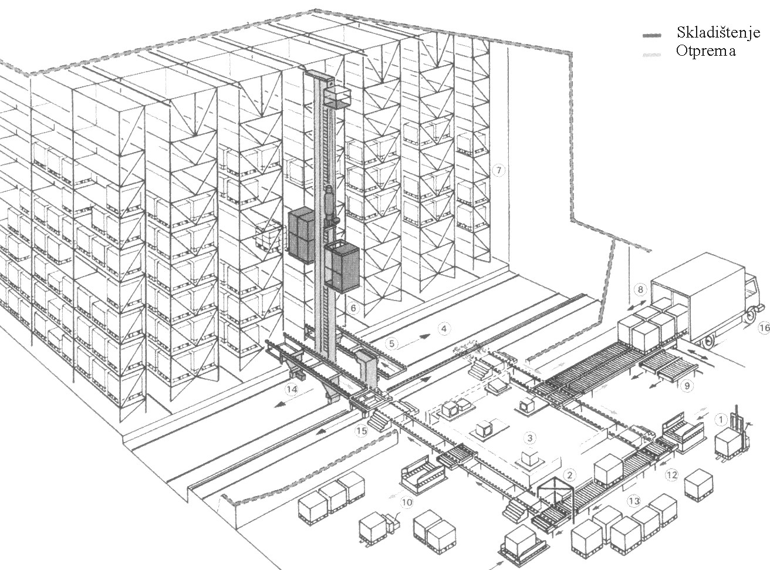

Fig.2: Name of figure, italic, center

LITERATURE

[1] MARKOVIC, М, Analysis ... ..., FTN,
Novi Sad, 2000. year.
[2] PETROVIC, P, Implementation... MF, Belgrade,
2001. year.

